Chapter 2, Solution 58

The 60 W light bulb in Fig. 2.122 is rated at 120 volts. Calculate the value of V_{s} to make the light bulb operate at its rated conditions.

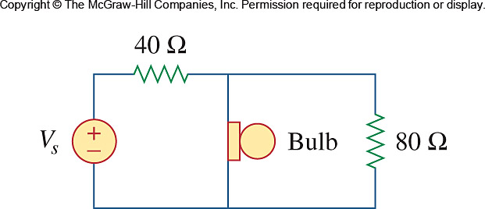

Figure 2.112
For Prob. 2.58.

Solution

The resistance of the bulb is (120)²/60 = 240 Ω

40 Ω
-
+

V_{S}
+

120 V
-

+ 90 V -

2 A

240 Ω

80 Ω

0.5 A

1.5 A

Once the 160Ω and 80Ω resistors are in parallel, they have the same voltage 120V. Hence the current through the 40Ω resistor is equal to 2 amps.

40(0.5 + 1.5) = 80 volts.

Thus

v_{s} = 80 + 120 = 200 V.

